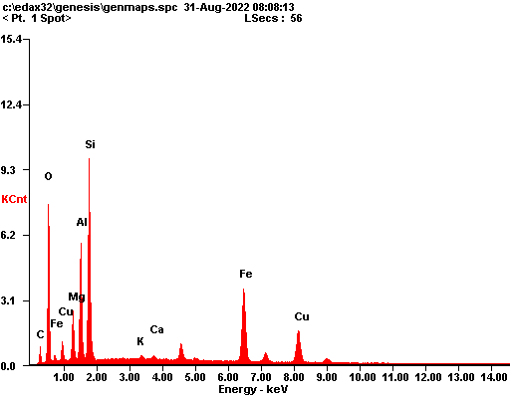

|  |  |  |
| --- | --- | --- |
| ***Element*** | ***Wt%*** | ***At%*** |
| ***CK*** | 11.67 | 20.57 |
| ***OK*** | 33.86 | 44.84 |
| ***MgK*** | 05.57 | 04.85 |
| ***AlK*** | 11.59 | 09.10 |
| ***SiK*** | 18.01 | 13.59 |
| ***KK*** | 00.33 | 00.18 |
| ***CaK*** | 00.27 | 00.14 |
| ***FeK*** | 10.77 | 04.08 |
| ***CuK*** | 07.93 | 02.64 |
| ***Matrix*** | Correction | ZAF |

